**BUILDING DRAWING PLANNING ESSENTIALS**

For making a building plan first need to set units according to the drawing. Unit can be set bu command UN then enter, then type will be architectural, precision will be 0’-0 1/4" and the insertion scale will be inches. After that, set the limits by commanding LIM then enter, then set drawing limits by specifying lower corner as 0,0 and the upper corner 100’,100’ according to this diagram. After that press Z enter A enter. There are 4 buttons need to on, ortho mode, dynamic input, object snap tracking and object snap.

After setting these two things, building planning happens in layers formats so we must have to set layers for building planning. In this planning,

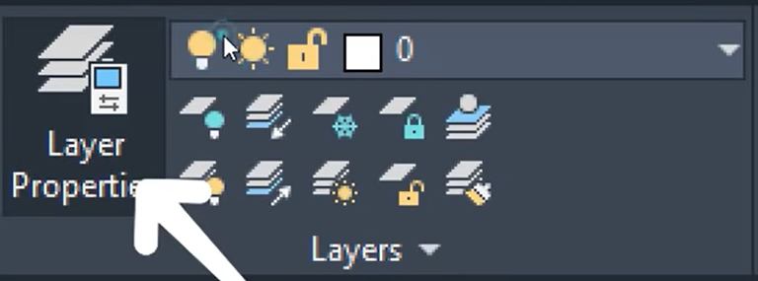

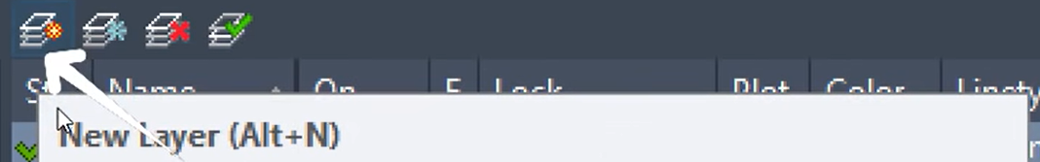

The ideal layers of a drawing are given below

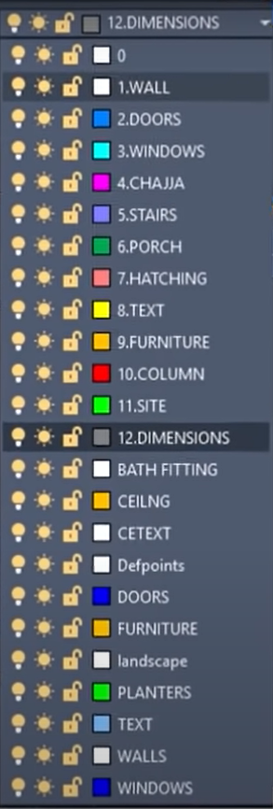

First, we make layers.

For chajja, linetype will be hidden.

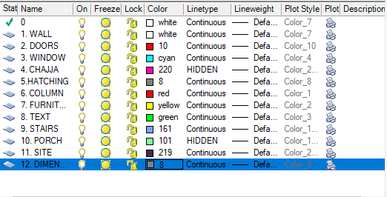

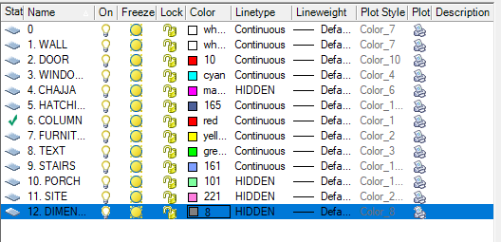

For the wall, line weight is set to 0.35mm,

These are the settings you can use for making drawings.

First, make a rectangle for the plot. The plot is 60’ X 50’.

Now creating the setback distance.

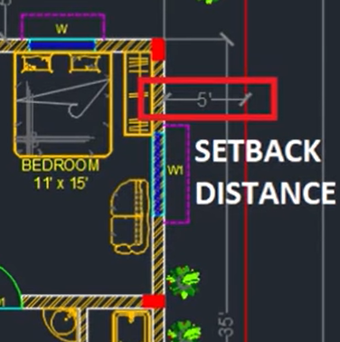

In this drawing the setback distance is 5’. Setback is generally made for entering air sunlight etc.

In front, the setback is set to 10’. The plot color line is changed to red. The white one is building the boundary.

From the building boundary, we need to take the external wall thickness which is taken as 9”.

This can be taken as an offset of 9”.

Similarly, the interior wall is made 4” to 6”. Here we will take 6”.



As seen in the picture below

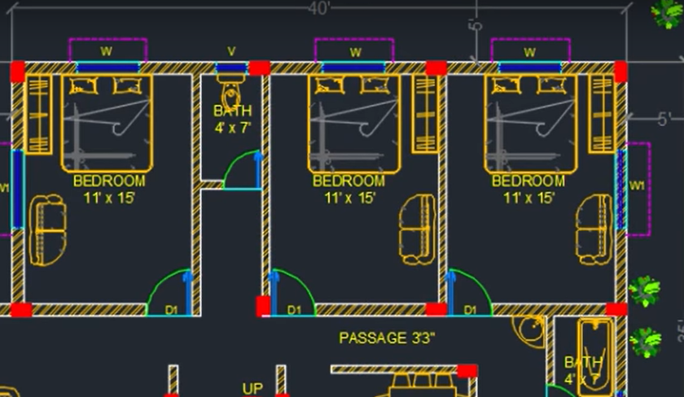

The bedroom length is 11’ X 15’. So, the offset need to take is 11’. Then again the offset need to take is 6-4” for interior walls.

So, the rooms are taken as the diagram shows.

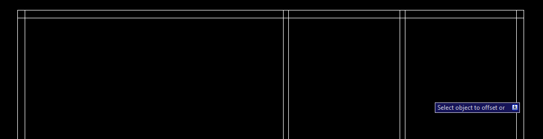

Now we need to take the bathroom that is 4’.

After taking all the dimensions of the rooms and walls now trim the rest of the line. For that, you can use the TR and single enter. Then take the boundary given in the picture

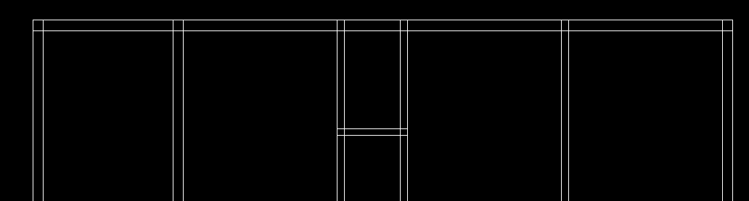



Select the bathroom portion joining which is marked above then press enter. Then rest of the line select remove. It takes the bathroom walls as a boundary and the rest of the line can be deleted easily. Also, you can use TR then double enter then you have to manually remove lines from every room.

Now for another rooms

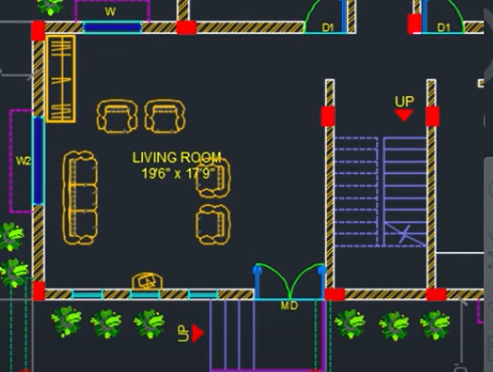

The diagram shows that the dimensions of the living room are 19’6” X 17’9” so let's make it. We can make it by using offset.

After making that now we can make the staircase which is given 6’6”. We can make this by using offset.

After making staircase now we will make kitchen.

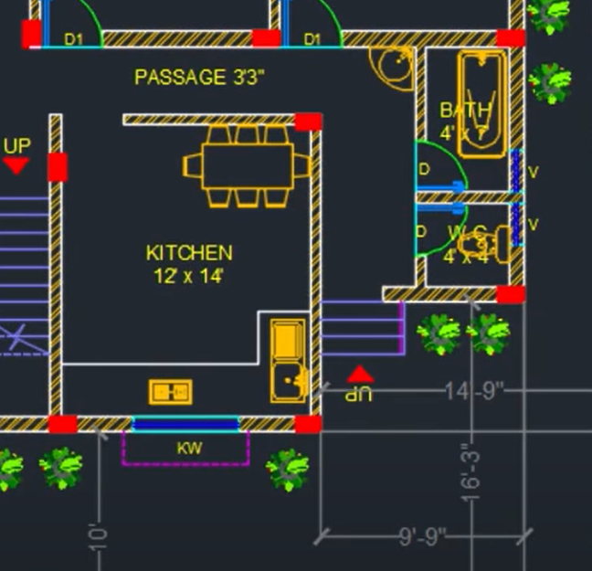

For the kitchen, it is shown the dimensions of the kitchen is given 12’ X 14’.

After completing all the rooms this will look like the below picture of the building drawing. This drawing also needs some doors and windows which will make now. 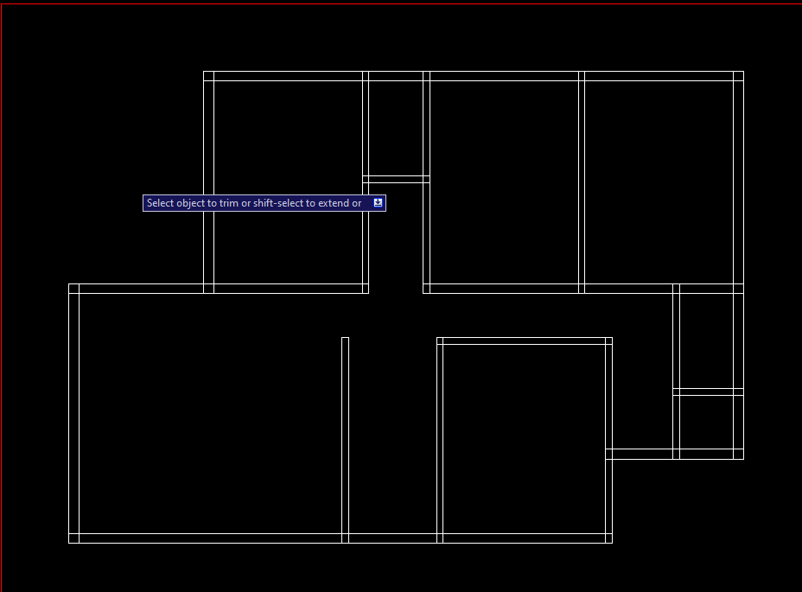

**Door and window size need to be known for making doors and windows of a room, kitchen, bathroom, and WC.**

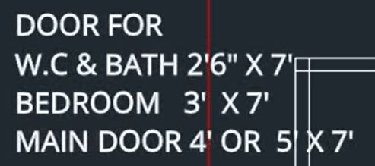

After providing all doors the diagram will look like this

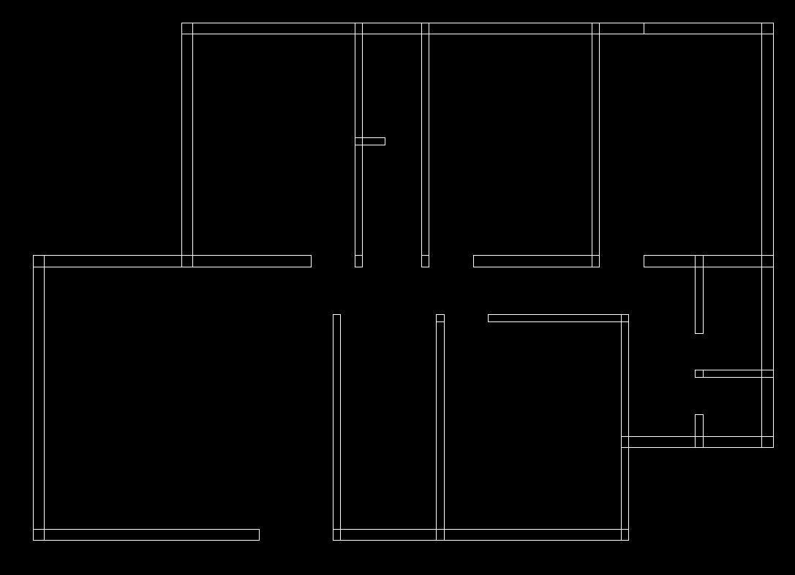



In the red marking it will be a main door of 5’, the kitchen in the blue marking, we will not provide any door in the kitchen but we need to provide a door-like space for entrance. Which will be 3’.

Before adding windows, we need to trim the rest lines because the windows comes in the middle and if we do not trim the lines then the window placement will be wrong. After trimming all lines, it will look like this.

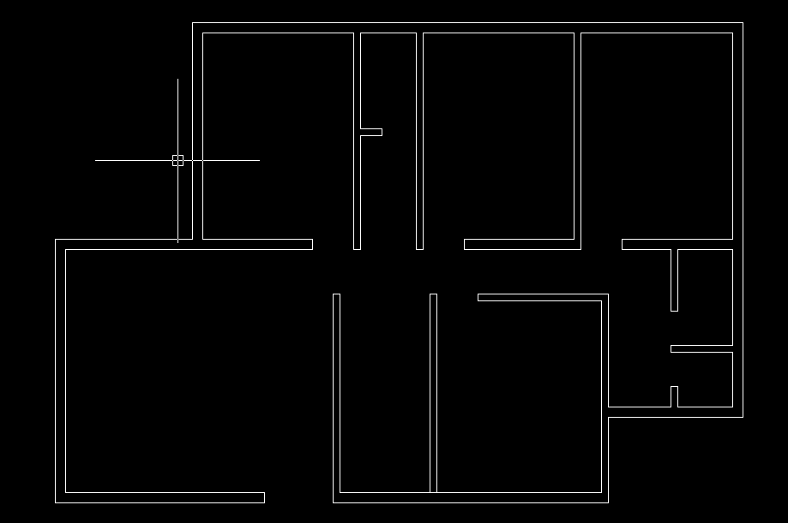

After making places for doors, now we will make windows. Generally smallest window size is 3’ but here we won't use that. Here we will use at least 4’. These windows we will make these outer from the plan and after making all things then copy the drawing to the specified places.

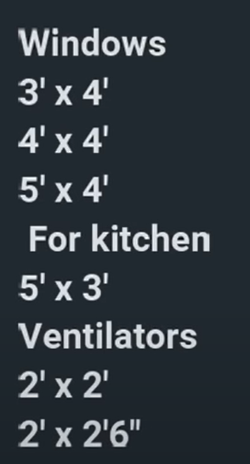

These are the dimensions for the windows.

For making the windows first change the layer then make a rectangle.



This is the dimension of the rectangle.

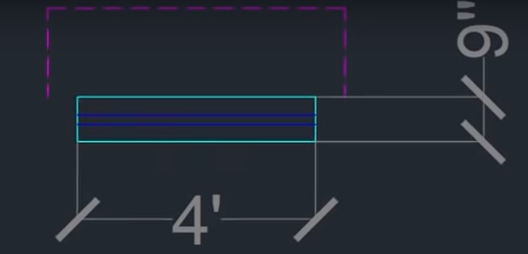

These are the dimensions for the windows in the main walls because the main wall thickness is 9”. After taking a rectangle take a line from the midpoint then take an offset of 1” in both the upper and lower direction.

After making the front windows we will make a chajja in these windows to complete the copy-paste process. For chajja, we will use polyline and change the layer to CHAJJA. For chajja we know that the size of the chajja is bigger than the window so, we will take 6” extra in both sides and the length of chajja will be 1’6”.

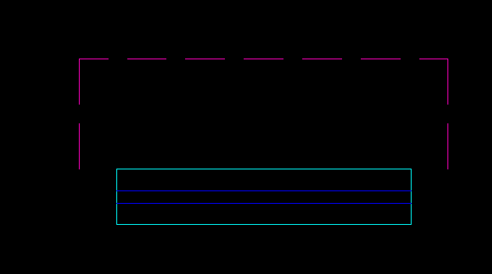

After making it look like this. After that save this into block which can be found on insert. If you make a symbol and you want to use the symbol multiple times then you can use that symbol in your plan multiple times and new plans as well. For making select the symbol (here window + chajja) then select create, then name appropriately, then click to pick point and select pick point (here midpoint). After making the block then copy the windows and make different lengths for different rooms. Here, 3 windows will be needed. First will be 1.2, second will be 1.5, and 3rd will be 1.8.

For changing the size of the window, we first need to explode the block, then we can change the dimension. We can use stretch for changing the size. For stretching the window, first click the stretch then half choose the window like shown below.

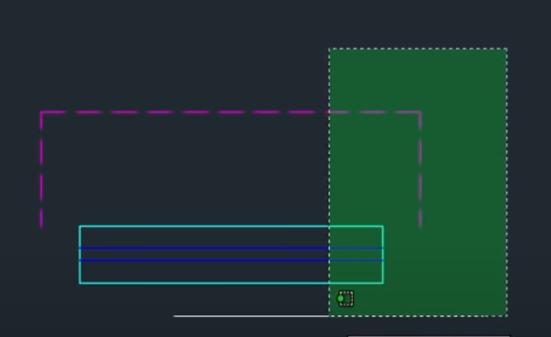

After pressing enter we can stretch the diagram like this

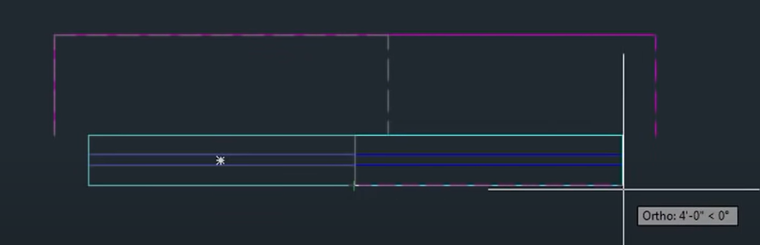

Give the length for stretching. (if I use 1’ then the length will increase by 1’ more this is the equation). Make the new windows into the block. After making all the things, then copy paste the windows in the places need. After making the windows in the building, in the lower portion there are three glass windows needed, for that you can make windows and then paste it here or you can make directly the windows. For that, you first change the layer to windows. For that make a line then offset that line of 2’ and make 3 glass windows in that portion as shown below.



Like this. In addition, load this in block for future need.

Also, we need ventilators in portion which I given the image



First, make a line in mid portion, and then take 1’ offset for length of the ventilator in both sides. Then take offset of 1” upper and lower as made for the windows. After making this ventilator, convert the ventilator into block for future usage. In addition, this ventilator we will use in the portion where necessary.

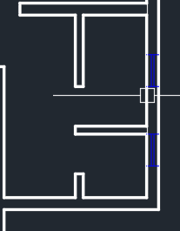

In this two portion ventilators are necessary, as these are the bathrooms and WC.

**Staircase**

For staircase, we will use the places that are assigned for staircase.

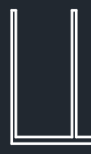

First we need to make a lending, for lending we can use the offset of 3’ which is the minimum lending length. After taking lending, it will look like this

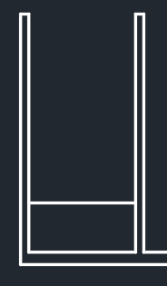

Next part is to make stairs. Make sure to change the layer of lending to stairs as took offset from the wall so that the layer made is wall layer.

For stair, we can again use offset. For stairs, the tread is 10” for each tread. And make 10 rises. After making the stair it will look like this

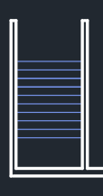

Now take a line in the middle and stairs are ready. After making full stairs it will look like this

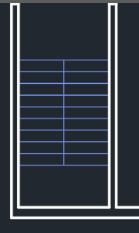

After making this we need a gap in between the stairs so we can make a 3-inch (3”) offset in both side and trim the mid portion. After making this the stair will look like this.

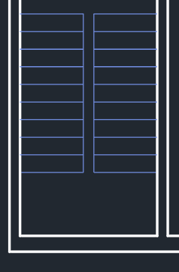

Now we can draw the staircase for verandah.

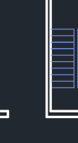

Here will be staircase for verandah. For that, we can take line from the edge and draw. In all direction, the lending distance will be 5’. After taking the lending, the image will be like this

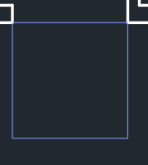

Now we need to take offset for tread. Here we will use 1’ tread. We can take 3 tread and join them with a line. Like this

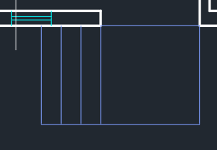

For railings, we can take offset of 2 inch (2”) and trim the places that are unnecessary and change the colour for railings if you need. Here I am changing the colour. After making it will look like this

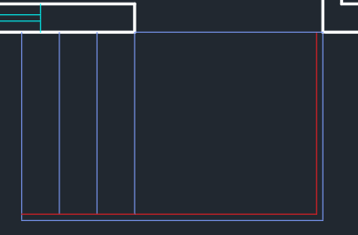

Also in this portion, we will use a staircase

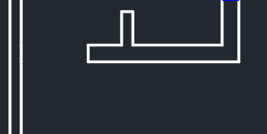

Here also the stairs need to make as before. After making it will look like this

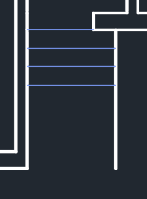

The wall is offset about 4’ and the stairs offset was 10” and the excess walls are trimmed and railing provided as shown in the figure.

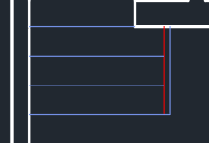

In the staircase, the half staircase is in hidden so making hidden first we need to off the orthomode. In addition, make a sign like the picture which shown below and the rest stairs make hidden and adjust the scale if necessary.

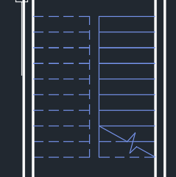

**Doors**

For making doors, AutoCAD already provides a symbol. If you press crtl+three (from the upper numbers of the keyboard) to open tool pallets which can provide the doors symbol. Then go to architecture and you can find “Door-Imperial” which need to be select, and then paste it to outer side of the plan because we need to copy that multiple time and change the layer to doors. This can be helpful to customize the opening of the door and we can set the size of the doors. In addition, we can change the orientation of the doors.

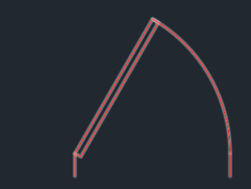

In addition, you can draw block for doors. Dimension for door will be 2” for starting, and then 3’ on the upper side, then again 2” in the left side and 3’ on lower side. Therefore, it will be a rectangle, then make handle for the doors like this (you can take any dimension here dimension is not necessary).

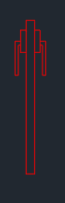

Then take a intersection point of the door hinge and handle outer bar and make a line of 3’ from there. Like this picture

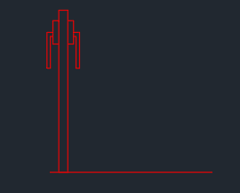

From the both ending, draw a circle (the center will be the center point of the door means the wall portion) and trim the excess points and finally the picture will look like this. Also make this as a block for future reference.

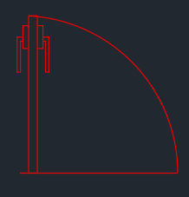

After making, mirror it for making all sides’s door for easy placements.

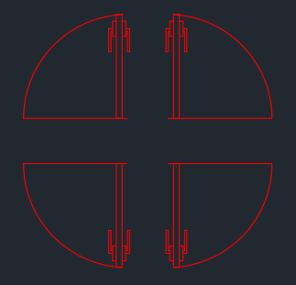

Now this set make a copy and rotate it. It will be easier for placements for all sides.

Now fit the doors in their places.

For the main door, we will use double panel doors.

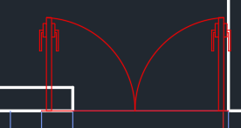

During placement, it can be seen that the doors are intersecting with the walls, so we can resize it. For resizing, select the scale option, select the both doors and select the size icon in the ribbon bar. Then it will ask to define the base point, base point will be the fixed point (which we do not want to change the point) and the other point will be changed (you can use the reference option also. Select reference then first select the fixed point, then the last point of the last door, then go to the place in where you want to put the door and press enter).

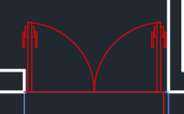

Next is to fit the doors for bath and toilet. Place the doors and use reference for easy scaling.

After placing all the doors in the plan, it will look like this

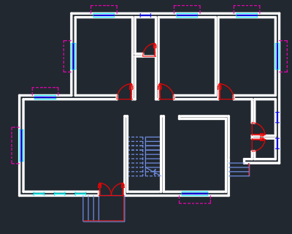

**Texting**

Now we can name the rooms.

For that select the text layer and select the text from the ribbon box. Then select the place in which you want to write and write. After writing, the look of the room be like this.